
FACULTY OF ENGINEERING
DIPLOMA ENGINEERING
DEPARTMENT OF COMPUTER ENGINEERING
SOFTWARE ENGINEERING (DE103304)

Unit-3 : Software Project Estimation & Scheduling

Responsibility of Software Project Manager
- Software project managers take the overall responsibility of project to success.
- The responsibilities and activities of a project manager are large and varied.
- Project Manager have following responsibilities:
    - Project proposal writing,
    - Project cost estimation,
    - Project scheduling,
    - Project staffing,
    - Deciding software process, Project monitoring and control, Risk management etc.
- The activities of Project manager classify into two major types of responsibilities.
- Project Planning:
  - Project planning involves estimating several characteristics of the project and then planning the project activities based on the estimates made.
  - Project planning consists of the following activities.
    - Estimation
    - Scheduling
    - Staffing
    - Risk Management
- Project monitoring and control activities:
  - The project monitoring and control activities are undertaken once the development activities start. ✓It ensures that the development proceeds as per the plan.

Skills required in project manager
- He must have theoretical knowledge of different project management techniques.
- A good decision making capabilities also required in project manager.
- He should be client representative and has to determine and implement the exact need of the client, and capable of understanding and discussing the problems with customers.
- He should have team leadership skill so the project which is divided into different persons are managed well and completed as per schedule.
- He should have the experience in the related area of the developing project.
- He must be able to monitoring and scheduling the progress of the project.
- Evaluating performance of each milestone of the project.

Metrics for size estimation
- The accurate estimation of the problem size is fundamental to satisfactory estimation of other project parameters such as effort, time duration for completing the project and the total cost for developing the software.
- The project size is a measure of the problem complexity in terms of the effort and time required to develop the product.
- Currently, two metrics are used to estimate size:
✓Lines of Code [LOC] ✓Function Point [FP]

Lines of Code [LOC]
- It is simplest and most widely used metric to estimate the project size.
- It is popular method.
- This metrics measures the size of a project by counting the number of source instruction in the developed program.
- During counting, the comments and blank lines should not be counted.
- Determining the LOC count at the end of a project is very simple. But, accurate estimation of the LOC count at the beginning of a project is very difficult.
- Disadvantages of LOC
  - LOC is language dependent. It focuses on coding activity only.
  - LOC gives numerical values of problem size, that is depending on coding style– different programmers lay out their code in different ways. For example, one programmer might write several source instructions on a single line whereas another might split a single instruction across several lines. This problem can be easily overcome by counting the language tokens in the program rather than the lines of code.
  - LOC measure with the quality and efficiency of code.
  - It measures lexical/textual complexity only.
  - Difficult to estimate LOC from problem description. So it is not useful for project planning
  - If a programmer uses several library routines, then the LOC count will be lower. This would show up as smaller program size.
  - It is very difficult to accurately estimate LOC in the final product from the problem specification. The LOC count can be accurately computed only after the code has been fully developed.
  - Therefore, the LOC metric is little use to the project managers during project planning, since project planning is carried out even before any development activity has started. This is the biggest shortcoming of the LOC metric.

Function point metric
- The function point metric overcomes many of the shortcomings of the LOC metric.
- The advantage of using the function point metric is that it can be used to easily estimate the size of a software product directly from the problem specification.
- But in LOC, the size can be accurately determined only after the product has fully been developed.
- In function point metric, the size of a software product is directly dependent on the number of different functions or features it supports.
- Each function when invokes reads some input data and transforms it to the corresponding output data.
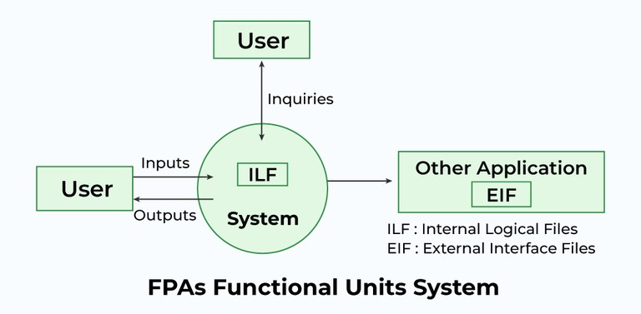
- Equation to count UFP
UFP = (Number of inputs)*4 + (Number of outputs)*5 + (Number of
Inquiries)*4 + (Number of Files)*10 + (Number of Interfaces)*10
- Different parameters to count the UFP (unadjusted function point) are:
  - Number of inputs
  - Number of Outputs
  - Number of Inquiries
  - Number of Files
  - Number of Interfaces.
Number of inputs:
Each data item input by the user is counted. It must be noted that individual data items input by the user are not considered in the calculation of the number of inputs, but a group of related inputs are considered as a single input.
For example, while entering the data concerning employee to pay roll software; the data items name, age, address, phone number, etc. are together considered as a single input. All these data items can be considered to be related, since they count as to a single employee.
Number of outputs:
The outputs considered refer to reports printed, screen outputs, error messages produced, etc. While outputting the number of outputs the individual data items within a report are not considered, but a set of related data items is counted as one input.
Number of inquiries:
Inquiries are user commands such as print-account-balance. Inquiries are counted separately. Number of files :
Each logical file is counted. A logical file means groups of logically related data.
Number of interfaces:
- Here the interfaces considered are the interfaces used to exchange information with other systems.
- Examples of such interfaces are communication links with other systems etc.
- Once the unadjusted function point (UFP) is computed, the technical complexity factor (TCF) is computed next. TCF refines the UFP measure by considering 14 other factors such as high transaction rates, throughput, and response time requirements, etc.
- Each of these 14 factors is assigned from 0 (not present) to 6 (strong influence). The resulting numbers are summed, gives the total degree of influence (DI).
- Now, TCF = (0.65+0.01*DI). As DI can vary from 0 to 70, TCF can vary from 0.65 to 1.35. Finally, FP=UFP*TCF.
- Advantages of Function Point✓It is not restricted to code.
  - It is language independent.
  - It is more accurate than estimate LOC.
  - We can have the measure from the specification that can‟t be done with LOC.
- Disadvantages of Function Point
  - It ignores the quality of output.
  - It is fully oriented to traditional data processing system.
  - It doesn‟t take into account the algorithmic complexity of software.

Project Estimation techniques
COCOMO (Constructive Cost Estimation Model):
COCOMO (Constructive Cost Estimation Model) was proposed by Boehm (1981). According to the Boehm any software development project can be classified into one of the following three categories based on the development complexity: organic, semidetached, and embedded.
- Organic: A development project can be considered of organic type, if the project deals with developing a well understood application program, the size of the development team is small, and the team members are experienced in developing similar types of projects.
- Semidetached: A development project can be considered of semidetached type, if the development consists of a mixture of experienced and inexperienced staff.
- Embedded:A development project is considered to be of embedded type, if the software being developed is strongly coupled to complex hardware.

Types of COCOMO Model:
  - Basic COCOMO Model
  - Intermediate COCOMO model III. Complete COCOMO model
I.Basic COCOMO Model
    - It is static, single values model that computes software development efforts using program size.
    - It is quick and rough estimation technique.
    - The basic COCOMO model gives an approximate estimate of the project parameters.
    - The basic COCOMO estimation model is given by the following expressions:
Expression:
Effort (E) = a1 * (KLOC)^{a2} PM Tdev = b1 * (Effort)^{b2} Months

Where
    - KLOC is the estimated size of the software product expressed in Kilo Lines of Code
    - a1, a2, b1, b2 are constants for each category of software products
    - Tdev is the estimated time to develop the software, expressed in months
    - Effort is the total effort required to develop the software product, expressed in person months (PMs)
Example: Assume that the size of an organic type software product has been estimated to be 32,000 lines of source code. Assume that the average salary of software engineers be Rs. 15,000/- per month. Determine the effort required to develop the software product and the nominal development time.
From the basic COCOMO estimation formula for organic software:
Effort = 2.4 х (32)^{1.05} = 91 PM
Development time = 2.5 х (91)^{0.38} = 14 months
Cost required to develop the product = 91 х 15000 = Rs. 1365000/-
II. Intermediate COCOMO model
- The intermediate COCOMO model recognizes this fact and refines the initial estimate obtained using the basic COCOMO expressions by using a set of 15 cost drivers (multipliers) based on various attributes of software development.
- For example, if modern programming practices are used, the initial estimates are scaled downward.
- If there are reliability requirements on the software product, this initial estimate is scaled upward.
- In general, the cost drivers can be classified as being attributes of the following items:
- Product: The characteristics of the product like reliability requirements of the product.
- Computer: Characteristics of the computer like execution speed required, storage space required etc.
- Personnel: experience level of personnel, programming capability, analysis capability, etc.
- Development Environment: use of the automation (CASE) tools used for software development.

III.Complete COCOMO model
- A major shortcoming of both the basic and intermediate COCOMO models is that they consider a software product as a single entity.
- However, most large systems are made up several smaller sub-systems. These subsystems may have widely different characteristics.
- For example, some subsystems may be considered as organic type, some semidetached, and some embedded. Not only that the development complexity of the subsystems may be different, but also for some subsystems the reliability requirements may be high, for some the development team might have no previous experience of similar development, and so on.
- The complete COCOMO model considers these differences in characteristics of the subsystems and estimates the effort and development time as the sum of the estimates for the individual subsystems.
- The following development project can be considered as an example of application of the complete COCOMO model.
- A distributed Management Information System (MIS) product for an organization having offices at several places across the country can have the following sub-components:
      - Database part
      - Graphical User Interface (GUI) part
      - Communication part
Of these, the communication part can be considered as embedded software. The database part could be semi-detached software, and the GUI part organic software. The costs for these three components can be estimated separately, and summed up to give the overall cost of the system.
Advantage of COCOMO model
- It is easy to use.
- It is repeatable process.
- It is versatile enough to support different model and levels.
- It is highly standardized, based on previous experience.
- It can be detailed documented.
•Disadvantages of COCOMO Model
- It ignores the hardware issues as well as the personal turnover level.
- It ignores all the documentation and requirements.
- It mostly depends on time factors.
- It limits the accuracy of software costs.
- It oversimplifies the impact of safety or security aspects.
- It also ignores customer skills, cooperation, and knowledge

❖ PROJECT SCHEDULING
i. Gantt Chart ii. Flow Chart iii. Sprint burn down chart for agile model Gantt Charts
- Gantt charts are mainly used to allocate resources to activities.
- The resources allocated to activities include staff, hardware and software.
- Gantt charts are useful for resources planning.
- A Gantt chart is a special type of bar chart where each bar represents an activity.
- The bars are drawn along a time line.
- The length of each bar is proportional to the duration of time planned for the corresponding activity.
- In the Gantt used for software project management, each bar consists of a white part and a shaded part.
- The shaded part of the bar shows the length of time each task is estimated to take.
- The white part shows the slack time, that is, the latest time by which a task must be finished.
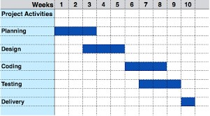
Flowchart:
Flowchart is Graphical or Pictorial Representation of problem.
Types of Flowcharts:
Process flowchart: it shows sequential steps of a process.
Data flowchart: Also known as data flow diagram (DFD). It is used to show the flow of data.
Business Process Modeling Diagram: Used to model the steps of planned business process.
Documentflowchart: Display the flow of documents.
System flowchart: Display how an entire system operates. Symbols of flowchart:
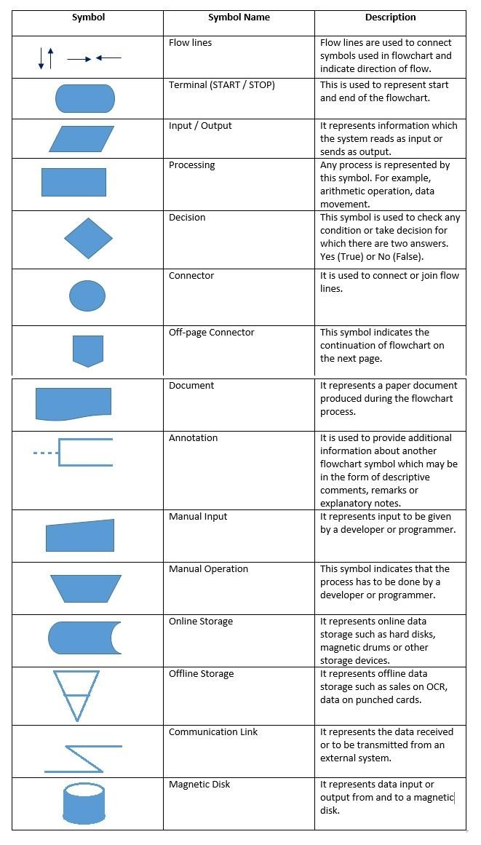

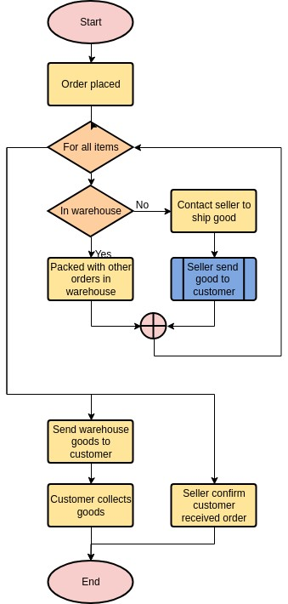

Sprint burn down chart for Agile model
- Burndown chart is a major parameter used in agile software development and scrum to detect how much work remains to be completed.
- It is the graphical representation of showing the left-out portion of the task versus time.
- It is highly used when a project is going to be done. The company gets the knowledge of „How the team members are working”, and “Can determine the accomplishment of the task”.
- From the burn-down chart graph, we can estimate when the project is going to be complete.
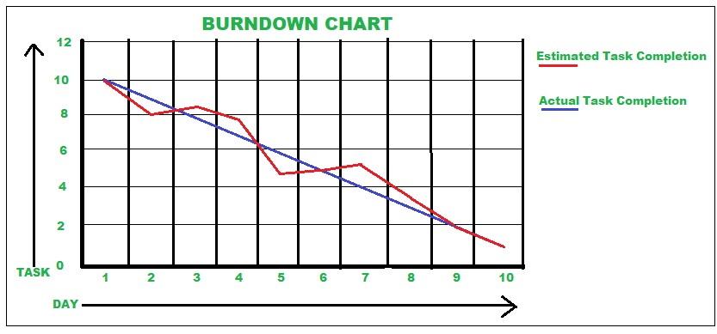

Risk Management
- A risk is any anticipated unfavorable event or circumstance that can occur while a project is underway.
- Risk management consists of three activities:
  - Risk Identification
  - Risk Assessment
  - Risk Containment
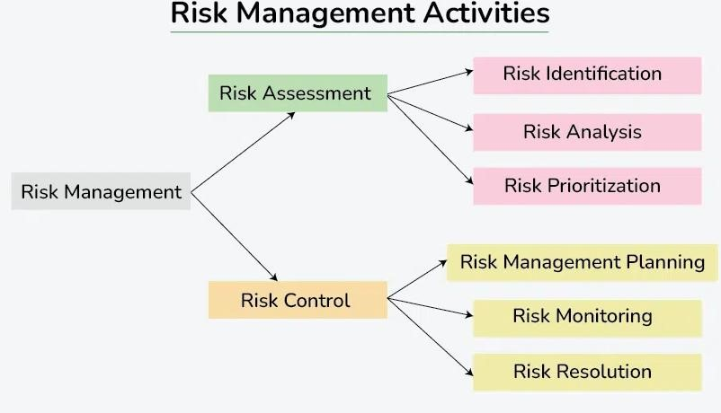

Risk Identification
- The project manger needs to anticipate the risks in the project as early as possible so that the impact of the risks can be minimized by making effective risk management plans.
- So, early identification is important.
- Risk identification is somewhat similar to listing down your nightmares.
- A project can be affected by a large variety of risks.
- There are three main categories of risks which can affect a software project as follows:
  - Project Risk
  - Technical Risk
  - Business Risk •Project Risk:
  - Project risks concern various forms of budgetary, schedule, personnel, resource, and customer related problems.
  - An important project risk is schedule slippage.
  - Since, software is intangible, it is very difficult to monitor and control a software project.
- Technical Risk:
  - Technical Risk concern potential design, implementation, interfacing, testing and maintenance problems.
  - Technical risks also include ambiguous specification, incomplete specification, changing specification etc.
  - Most technical risks occur due to the development team‟s insufficient knowledge about the product.
- Business Risks:
  - This type of risks includes risks of building an excellent product that no one wants, losing budgetary or personnel commitments.

Risk assessment
- The objective of risk assessment is to rank the risks in terms of their damage causing potential.
- For risk assessment, first each risk should be rated in two ways:
  - The likelihood of a risk coming true (r).
  - The consequence of the problems associated with that risk. (s).
  - Based on these two factors, the priority of each risk can be computed:
p = r * s
- Where p is the priority with which the risk must be handled, r is probability of the risk becoming true, and s is the severity of damage caused due to risk becoming true.

Risk containment
- After all the identified risks of a project are assessed, plans must be made to first contain the most damaging and the most likely risks.
- Different risks require different containment procedures.
- There are three main strategies to plan for risk containment.
- Avoid the risk:
  - Risks can be avoided in several ways, such as discussing with the customer to change the requirements to reduce the scope of the work, giving incentives to the developers to avoid the risk of manpower turnover.
- Transfer the risk:
  - This strategy involves getting the risky component developed by a third party, buying insurance cover, and so on.
- Risk reduction:
  - This involves planning ways to contain the damage due to risk.
  - For example, if there is risk that some key personnel might leave, new recruitment may be planned.
  - The most important thing to do in addressing technical risks is to build a prototype that tries out pieces of the technology that you are trying to use.

